Chapter 8, Problem 45.

In the circuit of Fig. 8.92, find v(t) and i(t) for t > 0.

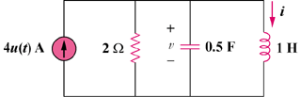

Figure 8.92
For Prob. 8.45.

